|  |  |
| --- | --- |
| SMART FARMING | CLOUD SERVICE |
| Project Name | Smart Farmer-IOT Enabled smart Farming application |

IBM Cloud services

Dashboard

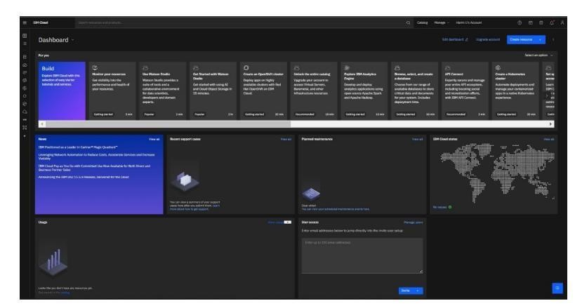

Account Settings

